The Cricket in Times Square Selected New York State’s 2024 Great Read

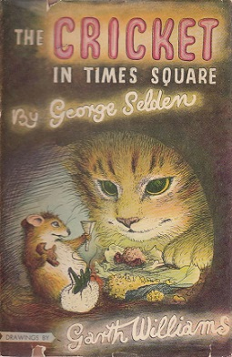

Every year, a list of books representing the literary heritage of the 50 states, the District of Columbia and the U.S. territories is celebrated by the Library of Congress's Center for the Book during the National Book Festival. Each book is selected by a Center for the Book state affiliate or state library that is for children and young readers. Books may be written by authors from the state, take place in the state, or celebrate the state’s culture and heritage.

The Empire State Center for the Book has selected the 1960 classic The Cricket in Times Square by George Selden and illustrated by Garth Williams to be New York State’s 2024 Great Read selection for the National Book Festival. The festival will take place on Saturday, August 24 in Washington DC.
This 1961 Newbery Honor book is the story of a country cricket who mistakenly travels to one of the busiest cities in the world. He is befriended by a caring young boy, a kind, streetwise city mouse and a protective and thoughtful cat.

For additional information contact Rocco Staino, rocco.staino@gmail.com, 914-475-3857

